**CareHUB Health Care System**

**SRS**

**Introduced by : SE2018G10**

**Table of Contents**

**1. Introduction 5**

*1.1 Purpose*

*1.2 Scope*

*1.3 Definitions, Acronyms, and Abbreviations*

*1.4 References*

*1.5 Overview*

**2. The Overall Description**

*2.1 Product Perspective*

2.1.1 System Interfaces

2.1.2 Interfaces

2.1.3 Operations

2.1.4 Site Adaptation Requirements

*2.2 Product Functions*

*2.3 User Characteristics*

*2.4 Constraints*

*2.5 Assumptions and Dependencies*

*2.6 Apportioning of Requirements*

**3. Specific Requirements**

*3.1 Functions*

*3.2 Performance Requirements*

*3.3 Logical Database Requirements*

*3.4 Software System Attributes*

3.4.1 Reliability

3.4.2 Availability

3.4.3 Security

3.4.4 Maintainability

3.4.5 Portability

**4. System Models**

**5. Document Approvals**

**6. Supporting Information**

# **1. Introduction**

*Healthcare is changing with a new emphasis on patient-centeredness.*

*Fundamental to this transformation is the increasing recognition of patients role in health care delivery and design. Medical appointment scheduling, as the starting point of most non-urgent health care services, is undergoing major developments to support active involvement of patients. By using the Internet*

*developments to support active involvement of patients. By using*

*as a medium, patients are given more freedom in decision making about their*

*preferences for the appointments and have improved access.*

## **1.1 Purpose**

## 

*Many hospitals -even governments- turned to website-based appointment service WAS and these are some examples of them:*

*Chinese government:*

*As a part of nationwide healthcare reforms, the Chinese*

*government launched web-based appointment systems (WAS) to provide a*

*solution to problems around outpatient appointments and services. These have*

*been in place in all Chinese public tertiary hospitals since 2009.*

## **1.2 Scope**

*CareHub Health Care System is a system that enables patients to accomplish three*

*tasks easily:*

*1) Find the right health provider to get treatment.*

*2)Retrieve medical records, such as test results and other health information.*

*3)Book appointments and scans easily with a button click.*

*Imagine the amount of effort that’ll be saved, all the hassle of looking for the right*

*doctor, and having to book appointments on ground, all this will be available from*

*home through this website.*

*All the needed information about the hospital will be available for the user.*

## **1.3 Definitions, Acronyms, and Abbreviations.**

*Provide the definitions of all terms, acronyms, and abbreviations required to properly interpret the SRS. This information may be provided by reference to one or more appendices in the SRS or by reference to documents. This information may be provided by reference to an Appendix.*

## **1.4 References**

*In this subsection:*

*(1) Provide a complete list of all documents referenced elsewhere in the SRS*

*(2) Identify each document by title, report number (if applicable), date, and publishing organization*

1. *Specify the sources from which the references can be obtained.*

*This information can be provided by reference to an appendix or to another document. If your application uses specific protocols or RFC’s, then reference them here so designers know where to find them.*

## **1.5 Overview**

*This document introduce Health Care System product’s SRS. It introduces general description, technical description*

**2. The Overall Description**

*The idea is to simply provide a service that facilitates patient care from home, The*

*patient will be provided with hospital info to help him reach the suitable*

*service for him, he’ll have a profile with his full medical record and it'll be updateable with his blood test results, and any prescriptions he takes.*

*The website will enable patients to know the hospital's available services, doctors, and clinics. It’ll also enable the patient to book appointments.*

*The patient will be able to rate the hospital's doctors, to provide continuous feedback to the hospital's staff.*

*There will be a Receptionist user that can use the system in the hospital to book for patients on ground.*

## **2.1 Product Perspective**

*The health care website provides ability to the hospital to serve the patients easily and makes the reservation processes a lot easier, it’s a self-contained product that organises the hospital system online and at the real ground.*

*The difference between it and any other health care system is that it’s not only reviewing the hospital info only, it contains the patient records stored in it’s database. updateable with doctors information to reach them and rate them. reservation of the clinics in the hospital and makes you aware of the available surgeries.*

*Business Objectives*

* *Offer easy and effective online Health Care Services.*
* *Offer online hospital system for medical institutions.*
* *Offer flexibility for patients to reserve their service.*
* *Offer an organized way to record the information*
* *Offer an upgraded online system.*

### **2.1.1 System Interfaces**

*The patient Interface: the patient with all the info he needs about the hospital.*

*It allows the patient to view the available clinics in details including the clinic’s doctor, the available time slots, and the price of each examination with every doctor in the staff. After that, the patient will be able to book an appointment in the desired clinic.*

*He will be provided with the price of each scan, the hospital can provide. He will be able to book the the desired scan or the desired blood test. He will be updated with the available time slots of the hospital’s scan rooms.*

*As each doctor will write a small brief about himself and his specialization, The patient will be able to view the staff of the hospital, which includes the doctors. He’ll be able to see their info(mail, mobile number), their specialization, and their rank/rate.*

*The patient can rate the doctors after appointments, the quality of the scans and the service provided by the hospital. He will be able to add his feedback to describe the treatment he had from the doctors, he dealt with and show the positives or negatives he noticed.*

*The patient will be provided with the working hours of the hospital’s pharmacy and a way of communication between him and them -mail or phone number-.*

*Each patient can create his own account on the site. He will get access to all the information and services, described before.*

*The receptionist interface: the receptionist to book appointments for patients in the hospital (on ground, not online).*

*The Receptionist will get access to each doctor’s time schedule. He will have limited ways to edit to them. He will get access also to every patient’s reservation whether it is scan or doctor examination.*

### **2.1.2 Interfaces**

*Patient Interface: It is a must to sign in or up before starting browsing anything in the website, will have the ability to go to services(clinics-surgeries-scans-pharmacy), doctors profiles, and his profile. he had the ability to edit his medical record and rate the doctors.*

*Receptionist Interface: It is a must to sign in before any process. he has only the access to reserve clinics and scans to the patient in the ground.*

### **2.1.**3 **Operations**

*Sign up: It’s the operation needed from the user to make an account for him and save his info and medical record to the Database.*

*Sign in: It’s the operation needed from the user to make to access the hospital info, doctors info, and his own profile, Also to give him the ability to book his appointment in the clinics.*

*The operation is same for receptionist but he has only access to schedules and can add to it for the patient in the ground.*

*Rating: Patient with profiles only can rate the doctors to make it obvious for the hospital how is the doctors work. And this rating is saved to the database and every time someone rate them it accumulates on it.*

*Reservation: The Patient has the ability to book all the hospital services online. This reservation is saved in the database which can be accessed by the admin (hospital receptionist) and he can reserve time slots for the patients who visit the hospital not only online.*

### **2.1.**4 **Site Adaptation Requirements**

*In this section:*

1. *Define the requirements for any data or initialization sequences that are specific to a given site, mission, or operational mode*
2. *Specify the site or mission-related features that should be modified to adapt the software to a particular installation*

*If any modifications to the customer’s work area would be required by your system, then document that here. For instance, “A 100Kw backup generator and 10000 BTU air conditioning system must be installed at the user site prior to software installation”.*

*This could also be software-specific like, “New data tables created for this system must be installed on the company’s existing DB server and populated prior to system activation.” Any equipment the customer would need to buy or any software setup that needs to be done so that your system will install and operate correctly should be documented here.*

## **2.2 Product Functions**

*User Management*

*• User management enables admins to control user access and on-board and off-board users to and from IT resources.*

*Observe Hospital information*

*• The user has the ability to observe the hospital’s history and information like contact numbers, hospital’s stay and environment, visiting hours and patient’s rights.*

*Registration*

*• The patient can sign up or sign in to the website to be able to access the hospital services and information and to be able to save his information to the database of the hospital and reuse it when it's needed.*

*Staff*

*• This section will show all the doctors with their specialization from the data base of the site. The patient can also get more details about the doctor if he clicked on him. • The patients can search for a specific doctor or a certain specialization. They can also see the staff of the hospital. • The system will frequently upload the patients feedback about doctors.*

*Doctor’s rating*

*• It’s a feature by which the patient can rate their doctors and give them feedback about their satisfaction in the appointment. The hospital can observe the rating of the doctors so it can change the staff to improve the hospital’s performance.*

*Clinics*

*Through this section the patient can know whether the doctor is available in the clinic or not. The patient can also see the available slots on any day and if a slot is taken by patient (x) , it will not appear to any other patient. However, the doctor would still appear to be available on that day.*

*Pharmacy*

*• It provides a feature to the user that he can know whether the pharmacy is open and available at this time or closed and provide the working hours and the off days*

*Scans*

*• The user has the ability to know the available scans (MRI, X RAYS, CT, and Ultrasound) in the hospital and the cost of each scan, also he has the ability to book an appointment for a certain scan.*

*Profile*

*• Patients Profile will display their personal information in addition to their medical Information, and medical condition.*

*• Patients Profiles will only be accessible by doctors or admins to provide privacy to the patient.*

*• Patient Profile will contain their contact info.*

*• There’ll be a Medical chart for the patient*

*Reservation*

*• The Patient has the ability to book all the hospital services online. This reservation is saved in the database which can be accessed by the admin (hospital receptionist) and he can reserve time slots for the patients who visit the hospital not only online.*

*Surgery*

*• The patient has the ability to know what surgeries are available in the hospital and the doctors who perform each surgery.*

*Patient’s Backlog*

*•A Log that provides the patient with all previous prescription and interactions with either a doctor or a hospital, Will also save the reservations done.*

## **2.3 User Characteristics**

All users must -at least- know the basics of using the internet.

There is no certain educational level for patients but they must know to read and write well.

Our main target to make patients spend less time in reservations and avoid going to the hospital then don’t find any free slots

The web site will be user-friendly anyone can find everything he needs easily without exerting any effort

## **2.4 Constraints**

*1- Access to the database of the pharmacy and the medicine inside it will be very difficult to do so we changed its function to be only tell the patient whether the pharmacy is open or closed*

*2- The user can only know the available clinics , scans and reserve in a slot*

*3-The user can know the available operations only*

*4- The web site will be a product sold to hospitals to manage all its stuff online*

## **2.5 Assumptions and Dependencies**

Assume that the website is a product can be bought to serve only one hospital at a time. It would give the owner a control panel to add or delete or edit in the product he bought.

Assumes that there will be a database of medical records hosted by a server. The server assumes it will be installed with a high-speed Internet connection to communicate with users.

Assume that the receptionist at the hospital has an interface for them to the website could let them book slots to patient. to make sure that the info is updated to the database at the server.

## **2.6 Apportioning of Requirements.**

*There is some functionality that currently lies outside of the scope of the current project, but could possibly be included in later releases. Two such options are the ability to include the pharmacy database and purchase from it online. contact the doctor online at emergency.*

# **3. Specific Requirements**

# 

Website Requirements

-It must allow a user to login.

-It must allow a user to logout.

-All information must be viewable on the website.

-All information must be updatable on the website.

- It must allow a user to download a backup of their medical information.

Server Requirements

-A correct combination of username and password is required for a user to login.

-A user must be logged on to be able to view or edit any medical information.

-Medical Records cannot be edited, only replaced by a new revision.

User Accounts

-Each account must securely store all of its data.

-Each account must have a separate identifying account number.

-Data must always be related to an account, and a user cannot view data he/she does not own.

Basic Information That Must be Stored

1.Username

2.Password

3.Address

4.Phone Number

5.First Name

6.Last Name

7.Middle Name

8.Date of Birth

9.Gender

10.Height

11.Weight

12.Blood Type

Complex Data That Must be Stored

-Health Care Providers

-Medical History

a)Medical Conditions

b) Medications

c)Procedures

-Tests

a) Labs

b)Tests

## **3.**1 **Functions**

*The System shall be divided into 4 areas in each area several functions should be provided.*

*Patient’s Area*

*In this area the system shall provide the user with the following functions.*

*-An Interface which Grants an access to all Doctor’s Profiles,Their Rates and Working hours, The Interface will be completely static.*

*-An Appointment Section where they can choose a date and time for a given clinic.*

*It should be flexible taken times can’t be appointed more than once*

*-A Backlog Sections gets updated with each action taken by the user or on the user such as prescriptions or scans,Inputs are from the Other Areas while the output is visible by the user.*

*-A Rating System following to each action taken by the user as appointments, scans and prescriptions through a Star System the input will be given by the user and the Output will be visible to the Other Area.*

*Receptionist’s Area*

*In this area the system shall provide the user with the following functions.*

*-An Interface that provides the user the access to present appointments to set their time and date for guests, This User has higher Privilege than patient’s as this user reserves on-field, Errors are handled in the database by limiting the interface with the non-reserved times, each reservation is checked in case of any error to prevent overwriting problems.*

*Doctor’s Area*

*In this area the system shall provide the user with the following functions.*

*-An Interface is provided to upload files as Prescriptions or scas to certain users backlog, the input is from the user while the output is seen in the Patient’s backlog.*

*-An Editing Area to Edit the static information visible to the Patients.*

*Admin’s Area*

*In this area the system shall provide the user with the following functions which ca be done under the superuser abilities in django.*

*-Full control of the users of other areas*

*-can access and edit all static information in the site*

*-can edit the privilage of each user*

## **3.**2 **Performance Requirements**

*This subsection specifies both the static and the dynamic numerical requirements placed on the software or on human interaction with the software, as a whole. Static numerical requirements may include:*

*(a) The number of terminals to be supported*

*(b) The number of simultaneous users to be supported*

*(c) Amount and type of information to be handled*

*Static numerical requirements are sometimes identified under a separate section entitled capacity.*

*Dynamic numerical requirements may include, for example, the numbers of transactions and tasks and the amount of data to be processed within certain time periods for both normal and peak workload conditions.*

*All of these requirements should be stated in measurable terms.*

*For example,*

*95% of the transactions shall be processed in less than 1 second*

*rather than,*

*An operator shall not have to wait for the transaction to complete.*

*(Note: Numerical limits applied to one specific function are normally specified as part of the processing subparagraph description of that function.)*

## **3.**3 **Logical Database Requirements**

*This section specifies the logical requirements for any information that is to be placed into a database. This may include:*

* *Types of information used by various functions*
* *Frequency of use*
* *Accessing capabilities*
* *Data entities and their relationships*
* *Integrity constraints*
* *Data retention requirements*

*If the customer provided you with data models, those can be presented here. ER diagrams (or static class diagrams) can be useful here to show complex data relationships. Remember a diagram is worth a thousand words of confusing text.*

## **3.**4 **Software System Attributes**

*There are a number of attributes of software that can serve as requirements. It is important that required attributes by specified so that their achievement can be objectively verified. The following items provide a partial list of examples. These are also known as non-functional requirements or quality attributes.*

*These are characteristics the system must possess, but that pervade (or cross-cut) the design. These requirements have to be testable just like the functional requirements. Its easy to start philosophizing here, but keep it specific.*

### **3.**4**.1 Reliability**

*Specify the factors required to establish the required reliability of the software system at time of delivery. If you have MTBF requirements, express them here. This doesn’t refer to just having a program that does not crash. This has a specific engineering meaning.*

### **3.**4**.2 Availability**

*Specify the factors required to guarantee a defined availability level for the entire system such as checkpoint, recovery, and restart. This is somewhat related to reliability. Some systems run only infrequently on-demand (like MS Word). Some systems have to run 24/7 (like an e-commerce web site). The required availability will greatly impact the design. What are the requirements for system recovery from a failure? “The system shall allow users to restart the application after failure with the loss of at most 12 characters of input”.*

### **3.**4**.3 Security**

*Specify the factors that would protect the software from accidental or malicious access, use, modification, destruction, or disclosure. Specific requirements in this area could include the need to:*

* *Utilize certain cryptographic techniques*
* *Keep specific log or history data sets*
* *Assign certain functions to different modules*
* *Restrict communications between some areas of the program*
* *Check data integrity for critical variables*

### 

### **3.**4**.4 Maintainability**

*Specify attributes of software that relate to the ease of maintenance of the software itself. There may be some requirement for certain modularity, interfaces, complexity, etc. Requirements should not be placed here just because they are thought to be good design practices. If someone else will maintain the system*

### **3.6.5 Portability**

*Specify attributes of software that relate to the ease of porting the software to other host machines and/or operating systems. This may include:*

* *Percentage of components with host-dependent code*
* *Percentage of code that is host dependent*
* *Use of a proven portable language*
* *Use of a particular compiler or language subset*
* *Use of a particular operating system*

*Once the relevant characteristics are selected, a subsection should be written for each, explaining the rationale for including this characteristic and how it will be tested and measured. A chart like this might be used to identify the key characteristics (rating them High or Medium), then identifying which are preferred when trading off design or implementation decisions (with the ID of the preferred one indicated in the chart to the right). The chart below is optional (it can be confusing) and is for demonstrating tradeoff analysis between different non-functional requirements. H/M/L is the relative priority of that non-functional requirement.*

|  |  |  |  |  |  |  |  |  |  |  |  |  |  |  |
| --- | --- | --- | --- | --- | --- | --- | --- | --- | --- | --- | --- | --- | --- | --- |
| **ID** | **Characteristic** | **H/M/L** | **1** | **2** | **3** | **4** | **5** | **6** | **7** | **8** | **9** | **10** | **11** | **12** |
| 1 | Correctness |  |  |  |  |  |  |  |  |  |  |  |  |  |
| 2 | Efficiency |  |  |  |  |  |  |  |  |  |  |  |  |  |
| 3 | Flexibility |  |  |  |  |  |  |  |  |  |  |  |  |  |
| 4 | Integrity/Security |  |  |  |  |  |  |  |  |  |  |  |  |  |
| 5 | Interoperability |  |  |  |  |  |  |  |  |  |  |  |  |  |
| 6 | Maintainability |  |  |  |  |  |  |  |  |  |  |  |  |  |
| 7 | Portability |  |  |  |  |  |  |  |  |  |  |  |  |  |
| 8 | Reliability |  |  |  |  |  |  |  |  |  |  |  |  |  |
| 9 | Reusability |  |  |  |  |  |  |  |  |  |  |  |  |  |
| 10 | Testability |  |  |  |  |  |  |  |  |  |  |  |  |  |
| 11 | Usability |  |  |  |  |  |  |  |  |  |  |  |  |  |
| 12 | Availability |  |  |  |  |  |  |  |  |  |  |  |  |  |

*Definitions of the quality characteristics not defined in the paragraphs above follow.*

*• Correctness - extent to which program satisfies specifications, fulfills user’s mission objectives*

*• Efficiency - amount of computing resources and code required to perform function*

*• Flexibility - effort needed to modify operational program*

*• Interoperability - effort needed to couple one system with another*

*• Reliability - extent to which program performs with required precision*

*• Reusability - extent to which it can be reused in another application*

*• Testability - effort needed to test to ensure performs as intended*

*• Usability - effort required to learn, operate, prepare input, and interpret output*

*THE FOLLOWING (3.7) is not really a section, it is talking about how to organize requirements you write in section 3.2. At the end of this template there are a bunch of alternative organizations for section 3.2. Choose the ONE best for the system you are writing the requirements for.*

## 4. System Models

# 4.1 Interaction models

**Use Case Diagrams:**

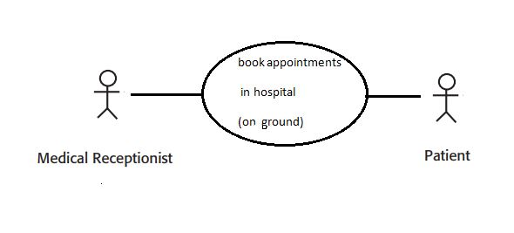

**Figure 1:show use-case where a patient come to book at the hospital**

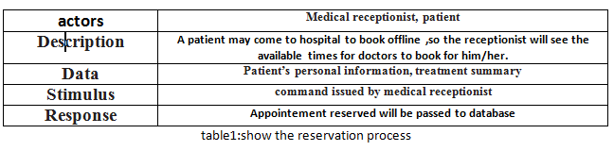

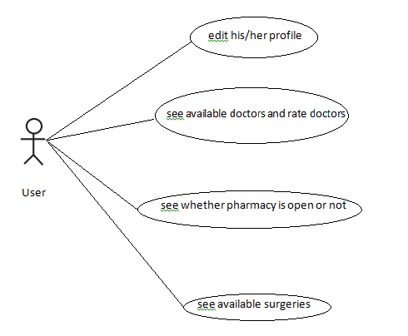

Figure 2:shows how user may interact with the careHub system.

*Figure 2 shows a use case for users interaction with careHub system,he/she may have a profile and edit his/her profile with his medical records,this medical records includes his/her blood type, whether he/she has allergy to certain drugs, a history of the treatments and prescriptions and everything that could help any other doctor to treat this patient.*

*Also he/she patient can rate the doctors after appointments, the quality of the scans and the service provided by the hospital. He/she will be able to add his feedback to describe the treatment he/she had from the doctors, he/she dealt with and show the positives or negatives he/she noticed.*

*Through careHub the patient can check the available clinics in the hospital and their costs. The patient can also book appointments to the clinics he needs. And reserve his slot of time and day.*

*The patient can also check the available scans in the hospital and their costs. The patient can book appointment to the scan he needs. And reserve his slot of time and day. In addition to that the patient can check if the pharmacy is available at the mean time and its days off, and working hours.*

# 4.2 Class Diagram

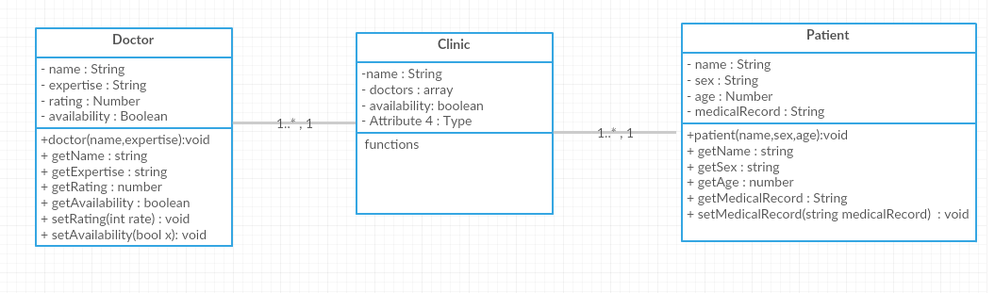

# 5. **Supporting Information**

*The supporting information makes the SRS easier to use. It includes:*

* *Table of Contents*
* *Index*
* *Appendices*

*The Appendices are not always considered part of the actual requirements specification and are not always necessary. They may include:*

*(a) Sample I/O formats, descriptions of cost analysis studies, results of user surveys*

*(b) Supporting or background information that can help the readers of the SRS*

*(c) A description of the problems to be solved by the software*

*(d) Special packaging instructions for the code and the media to meet security, export, initial loading, or other requirements*

*When Appendices are included, the SRS should explicitly state whether or not the Appendices are to be considered part of the requirements.*